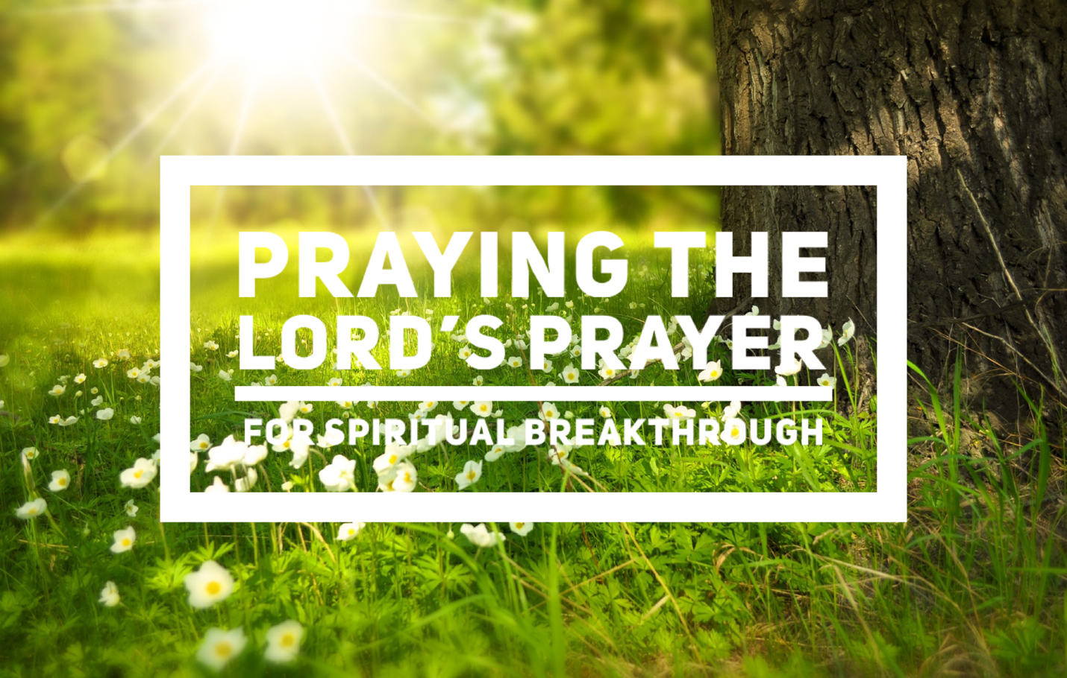

**PRAYING THE LORD’S PRAYER FOR SPIRITUAL BREAKTHROUGH**

40-Day Prayer Challenge and “GROWING IN PRAYER” BOOK STUDY

June 4 – July 13, 2023

WEEK 1: June 4 – 10 -- Chapters 1-2

WEEK 2: June 11 – 17 – Chapters 3-4

WEEK 3: June 18 – 24 – Chapters 5-6

WEEK 4: June 25 – July 1 –Chapters 7-8

WEEK 5: July 2 – 8 – Chapters 9-10

WEEK 6: July 9 – 13 –Chapter 11