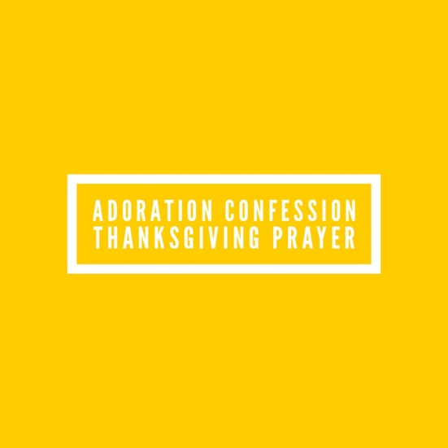

E.M. Bounds said, “Prayers outlive the lives of those who uttered them; outlive a generation, outlive an age, outlive a world.” So, let’s keep praying!

Evangelism Explosion International has just successfully completed all of the continental Congresses in a closing session in Malaysia on Friday, August 11, 2023. We’d like to thank our Heavenly Faither for the successful series of Congresses. We would like to thank God for the work of all the continental teams and their leadership structures, as well as our EE President, Dr. John Sorensen, our Vice Presidents, our operational teams which made these Congress series the success that they were.

We would like to thank God for His favor and we believe that all of this was possible because of the intensive prayer support in preparation of Congress and during the Congresses. God has done great things and should be greatly praised. Please join our EE family as we pray for diligent follow through by every leader and every delegate of every nation represented, as each embraces the skills taught and the information transferred, for the growth of the ministry and the expansion of the Kingdom of our Lord Jesus Christ for such a time as now.

These words paraphrased from our EE International Board member, Malcolm Thomas.

**A**DORATION:

Lord, my God, You are God in the heavens above and in the earth below. Joshua 2:11

You stretch out the earth over empty space; You suspend the earth on nothing. Job 26:7

You made the Pleiades and Orion and turn deep darkness into morning and darken day into night. You call for the waters of the sea and pour them out over the face of the earth ----The Lord is Your name. Amos 5:8. You are with us through every battle we face, through every circumstance we find ourselves in, through every hurt, hang up and heartache. You are always with us. You are the way, the truth, the life. You are our hiding place, a great fortress, our portion forever. Through every blessing, every promise, every breath we take You are provider, protector, our refuge. You meet with us daily and Your mercies are new every morning.

**C**ONFESSION:

You, O Lord, have declared, “Even now

Return to Me with all your heart,

With fasting and weeping and mourning.

So, rend your heart and not your garments.”

We will return to You, O Lord our God,

For You are gracious and compassionate,

Slow to anger and abounding in lovingkindness,

And You relent from sending calamity. Joel 2:12-13

Hear from heaven, Your dwelling place, and forgive us and deal with each of us according to what we do, since You know our hearts (for You alone know people’s hearts). 2 Chronicles 6:30

Reveal any sin that needs to be confessed. We want to be a people that is pure and holy before You, our Holy God. Sin no longer has a hold over us, shame has no power over us, we’ve been washed clean but when “that which I would not, that do I do” shows up in the course of our day reveal it immediately so that we do not fall into any pattern of sin.

**T**HANKSGIVING:

The salvation of the righteous comes from You, Lord;

You are their stronghold in time of trouble.

You help them and deliver them;

You deliver them from the wicked and save them,

Because they take refuge in You. Psalm 37:39-40

You’ve set us free, washed us clean, redeemed us by Your precious blood.

Thank you for removing the chains, the blindness, that once caused us to walk in darkness and separation from You. Your grace is amazing and You are alive within us. Thank you, Lord, that we’ve been crucified with Christ and never the lest we live but you Christ live within us.

**S**UPPLICATION:

When I am afraid, I will trust in You,

O God, whose word I praise.

In You I have put my trust,

I will not fear;

What can mere mortals do to me? Psalm 56:3-4

Whatever I do, whether in word or in deed, may I do it all in Your name, Lord Jesus, giving thanks to God the Father through You. May I abide in You, O Christ, so that when You appear, I will have confidence and not be ashamed before You at Your coming. God, here I am running to You again and again. I fall into Your grace. Continue to mold me and shape me into Your image so I can be used for highest calling.

**(Ministries of EE: Share Your Faith Workshop, Everyday Evangelism, Hope for Kids, XEE)**

|  |  |  |  |  |
| --- | --- | --- | --- | --- |
| SYFW | 9/9/23 | Providence Presbyterian Church | York, PA | Led by Shibu Oommen |
| SYFW | 9/9/23 | Fellowship Bible Church of Tulsa | Tulsa, OK | Led by Lester Vogler and Chris Lorenz |
| SYFW | 9/9/23 | Resonate Jesus Christ | St. Helens, OR | Led by John Rist |
| SYFW | 9/16/23 | Shields Blvd. Baptist Church | Oklahoma City, OK | Led by Lester Vogler and Christ Lorenz |
| SYFW | 9/16/23 | Faith Presbyterian Church | Wilmington, DE | Led by Shibu Oommen |
| SYFW | 9/10/23 | Trinity Baptist Church | Alma, AR | Led by Don Snipes |
| SYFW | 9/16/23 | Shields Blvd Baptist Church | Oklahoma City, OK | Led by Lester Vogler and Chris Lorenz |
| SYFW | 9/23/23 | Christo Mar Thoma | Philadelphia, PA | Led by Shibu Oommen |
| SYFW | 9/30/23 | First Baptist Church | Cincinnatus, NY | Led by Shibu Oommen |
| SYFW | 10/7/23 | Center Point Church | Smyrna, DE | Led by Shibu Oommen |
| SYFW | 10/7/23 | Grace Tabernacle Baptist Church | Lyndhurst, OH | Led by Don Workman |
| SYFW | 10/14/23 | Shiloh Baptist Church | Lorton, VA | Led by Dan Wheeler |
| SYFW | 10/28/23 | Faith Baptist Church | Streetsboro, OH | Led by Don Workman |
| EV2 Clinic | 9/14/23 | Wildwood Church | Tallahassee, FL | Bill McClain and Keith Hood |
| EV2 Clinic | 9/21/23 – 9/22/23 | Mid-America Baptist Theological Seminary | Cordova, TN | Led by Don Snipes |
| EV2 Clinic | 9/28/23 – 9/29/23 | Iglesia Santuario | Raleigh, NC | Led by Olvin and Marisol Gutierrez |
| EV2 | 10/6 – 10/6/23 | Southern Hills Baptist Church | Oklahoma City, OK | Led by Lester Vogler and Chris Lorenz |
| EV2 | 3/14/24 | St. John Missionary Baptist Church | Oklahoma City, OK | Led by Lester Vogler, Art Halley, and Wallace Lewis |
| EV2 | 4/11/24 | First Baptist Church Rogers | Rogers, AR | Led by Don Snipes |
| EV2 | 7/25/24 | First Baptist Church Rogers | Rogers, AR | Led by Don Snipes |
| HFK | 9/29/23 | Global Missions Church | Silver Spring, MD | Led by Dot Yanes Horstman |
| HFK | 11/3/23-11/4/23 | Simpson Creek  Baptist Church | Bridgeport, WV | Beth Workman |
| Weavers: From the Inside Out | 9/5/23 to 9/26/23 | Contact: weavers@eeworks.org |  | Ministry Coordinator: Elenore Beach |
| Weavers Evangelism | 9/28/23 to 11/16/23 | Contact: weavers@eeworks.org |  | Ministry Coordinator: Elenore Beach |
| Speechless Moments | 11/3/23 to 11/24/23 | Contact: weavers@eeworks.org |  | Ministry Coordinator: Elenore Beach |